Experiment Number : 06 Date: 5-02-26

ABSTRACT CLASSES
Aim:
To understand and implement inheritance concepts in Java.
PRE LAB EXERCISE
QUESTIONS
- What is an abstract class?
An abstract class is a class that:
- Cannot be instantiated (you cannot create objects of it)
- Can contain both abstract methods (without body) and normal methods (with body)
- Is meant to provide a base for other classes to extend
Example:
abstract class Animal {
abstract void sound(); // abstract method
void sleep() { } // normal method
}

- Why are abstract methods used?
Abstract methods are used when:
- You want to force all subclasses to provide their own implementation.
  - They act like a template.
- They help achieve polymorphism.
- They help in designing common structure but different behaviors.
- They ensure method consistency across subclasses.
Example:
abstract class Shape {
abstract void draw(); // every shape must define its own draw()
}

- Difference between abstract class and interface.
Abstract Class | Interface
Can have abstract + concrete methods | Earlier only abstract methods; now can have default & static methods
Can have variables, constructors, blocks | No constructors; only constants (public static final)
Supports single inheritance | Supports multiple inheritance
Used for partial abstraction | Used for full abstraction
Methods can have any access modifier | Methods are public by default
Cannot be instantiated | Cannot be instantiated

IN LAB EXERCISE
Objective:
To implement abstract class and demonstrate abstraction.
PROGRAMS:
1.University System
Scenario:
A university has different types of courses: Online, Offline, and Hybrid. Each course has a getDetails() method.
Question:
Create an abstract class Course with abstract method getDetails(). Implement OnlineCourse, OfflineCourse, and HybridCourse classes.
Code:
package tutorial;
import java.util.Scanner;

public class abs {
public static void main(String[] args) {
Course c1 = new OnlineCourse();
Course c2 = new OfflineCourse();
Course c3 = new HybridCourse();
c1.getDetails();
c2.getDetails();
c3.getDetails();
}
}

abstract class Course {
abstract void getDetails();
}
class OnlineCourse extends Course {
void getDetails() {
System.out.println("Online Course: Attend via Internet");
}
}
class OfflineCourse extends Course {
void getDetails() {
System.out.println("Offline Course: Attend in classroom");
}
}

class HybridCourse extends Course {
void getDetails() {
System.out.println("Hybrid Course: Combination of online and offline");
}
}
Output:
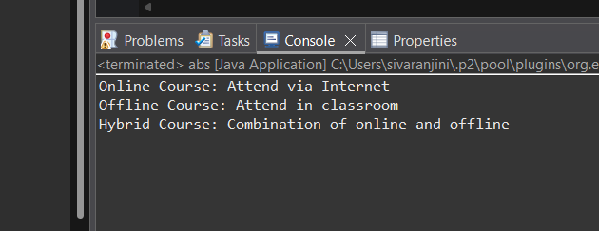
2. Employee Payroll System
Scenario:
A company has different types of employees — Regular and Contract. All employees have a salary, but the calculation differs for each type.
Question:
Design an abstract class Employee with an abstract method calculateSalary(). Implement subclasses RegularEmployee and ContractEmployee to calculate salary differently.
Code:
import java.util.Scanner;
abstract class Employee {
String name;
double baseSalary;

// Abstract method to calculate total salary
abstract void calculateSalary();
}

class RegularEmployee extends Employee {
double bonusRate = 0.1; // 10% bonus

void calculateSalary() {
double totalSalary = baseSalary + (baseSalary * bonusRate);
System.out.println("Regular Employee: " + name);
System.out.println("Base Salary: " + baseSalary);
System.out.println("Total Salary (with 10% bonus): " + totalSalary);
}
}

class ContractEmployee extends Employee {
void calculateSalary() {
System.out.println("Contract Employee: " + name);
System.out.println("Total Salary: " + baseSalary);
}
}

public class Main {
public static void main(String[] args) {
Scanner sc = new Scanner(System.in);

// Input for Regular Employee
System.out.print("Enter Regular Employee Name: ");
String regName = sc.nextLine();
System.out.print("Enter Base Salary: ");
double regSalary = sc.nextDouble();
sc.nextLine(); // Consume newline

// Input for Contract Employee
System.out.print("Enter Contract Employee Name: ");
String conName = sc.nextLine();
System.out.print("Enter Base Salary: ");
double conSalary = sc.nextDouble();

// Create objects
Employee e1 = new RegularEmployee();
e1.name = regName;
e1.baseSalary = regSalary;

Employee e2 = new ContractEmployee();
e2.name = conName;
e2.baseSalary = conSalary;

System.out.println("\n--- Salary Details ---");
e1.calculateSalary();
System.out.println();
e2.calculateSalary();

sc.close();
}
}
Output:
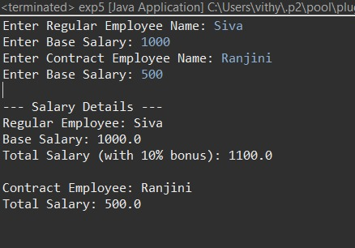

3.Banking System
Scenario:
A bank has different types of accounts: Savings and Current. Both accounts need a method to calculate interest, but the calculation differs for each account type.
Question:
Use an abstract class BankAccount with an abstract method calculateInterest() and implement it in SavingsAccount and CurrentAccount classes.
Code
abstract class BankAccount {
String accountHolder;
double balance;

BankAccount(String name, double bal) {
accountHolder = name;
balance = bal;
}

abstract void calculateInterest(); // Abstract method
}

class SavingsAccount extends BankAccount {
double interestRate = 0.04; // 4% interest

SavingsAccount(String name, double bal) {
super(name, bal);
}

void calculateInterest() {
double interest = balance * interestRate;
System.out.println("Savings Account Interest for " + accountHolder + " = " + interest);
}
}

class CurrentAccount extends BankAccount {
double interestRate = 0.02; // 2% interest

CurrentAccount(String name, double bal) {
super(name, bal);
}

void calculateInterest() {
double interest = balance * interestRate;
System.out.println("Current Account Interest for " + accountHolder + " = " + interest);
}
}

public class Main {
public static void main(String[] args) {
BankAccount acc1 = new SavingsAccount("Ram", 50000);
BankAccount acc2 = new CurrentAccount("Ravi", 80000);

acc1.calculateInterest();
acc2.calculateInterest();
}
}

Output
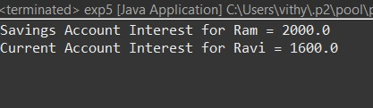
POST LAB EXERCISE
- How is an abstract class different from a regular class?
Abstract Class | Regular Class
Cannot be instantiated | Can be instantiated
May contain abstract methods (without body) | Cannot contain abstract methods
May contain both abstract and concrete methods | Contains only concrete methods
Used for incomplete, conceptual design | Used for fully implemented classes
Must be inherited by a subclass | Can be used directly

- Can you create an object of an abstract class? Why or why not?
No, you cannot create an object of an abstract class.

Reason:
An abstract class may contain incomplete methods (abstract methods without body), so Java does not allow creating objects of such classes.
They exist only to be extended by subclasses.

- What happens if a subclass does not implement an abstract method?
Two possible outcomes:

If the subclass is not declared abstract

If the subclass is declared abstract
👉 It is allowed.
The subclass can skip implementation but then it also becomes abstract.
- Can an abstract class exist without any abstract methods?
Yes, it can.
An abstract class may contain only:
- Concrete methods
- Variables
- Constructors
But if you mark it abstract, it cannot be instantiated.
This is useful when you want to:
- Prevent object creation
- Provide a base class for shared code
- Provide common functionality for subclasses
- Can an abstract class extend another abstract class?
Yes.
An abstract class can extend another abstract class.
Example:
abstract class A {
abstract void show();
}

abstract class B extends A {
void display() { }
}
- Class B is abstract
- B does not need to implement A’s abstract methods
- The first non-abstract subclass must implement them

Result:

Thus the abstract classes and methods were implemented and executed successfully.

ASSESSMENT

Description | Max Marks | Marks Awarded
Pre Lab Exercise | 5
In Lab Exercise | 10
Post Lab Exercise | 5
Viva | 10
Total | 30
Faculty Signature

